600T Series

From 1 to 4 tm class Amco Veba's 600T series for light vehicles is the well known compact telescopic Amco Veba range Thanks to the light weight, small installations space and wide accessories available, the 600T series represents the perfect solution for several applications on trucks, trailers and pick ups. It allows to perform any kind of loading and unloading activity with maximum flexibility. All our users in the entire world appreciate this range since many years. Compact High capacity Perfect combination of cost and performance

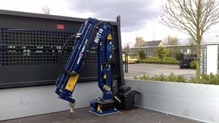

601T

Max. Lifting capacity (kg)

860

Lifting Moment Class (tm)

1

Max. Extension reach (m)

2.79

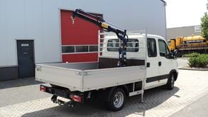

602T

Max. Lifting capacity (kg)

860

Lifting Moment Class (tm)

1

Max. Extension reach (m)

2.79

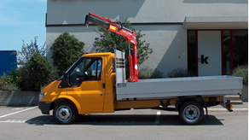

603T

Max. Lifting capacity (kg)

1590

Lifting Moment Class (tm)

2

Max. Extension reach (m)

4.17

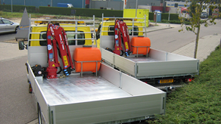

604T

Max. Lifting capacity (kg)

2055

Lifting Moment Class (tm)

3

Max. Extension reach (m)

4.25

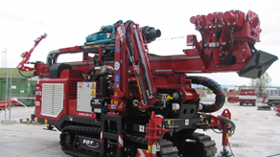

605T

Max. Lifting capacity (kg)

2390

Lifting Moment Class (tm)

4

Max. Extension reach (m)

5.91